SIMATS ENGINEERING CO-2 ASSESSMENT TOOL 3
Name: C Prasanna Reg no: 192371035
Course code: ITA1407

Topic 1: Footprinting Tools – Conducting Competitive Intelligence
1.A cybersecurity consultant has been assigned to perform a passive security assessment for a company named
ABC Technologies. The consultant must collect publicly available information without directly interacting
with the company’s servers.
Task: Apply suitable footprinting tools to identify the company’s:
- domain registration details,
- employee email addresses,
- technology stack,
- and publicly exposed subdomains.
Explain how each selected tool helps in conducting competitive intelligence.
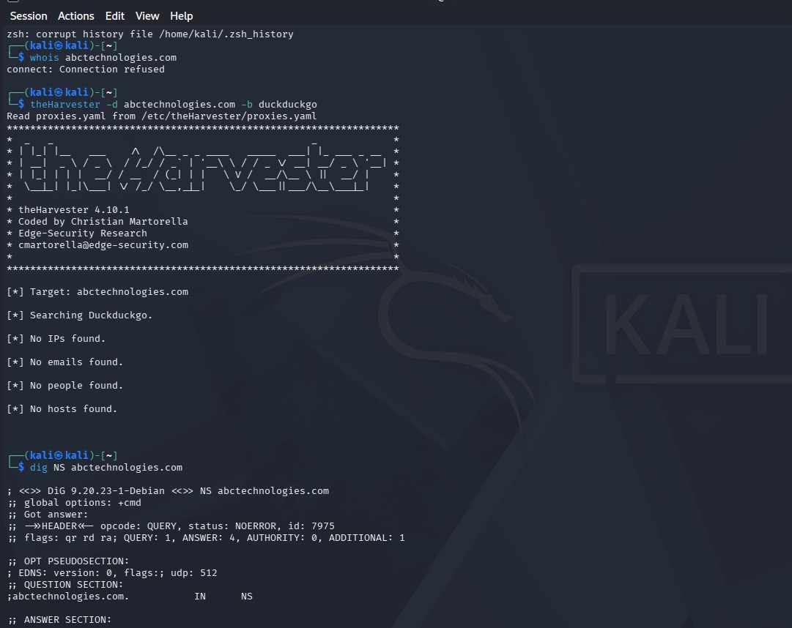

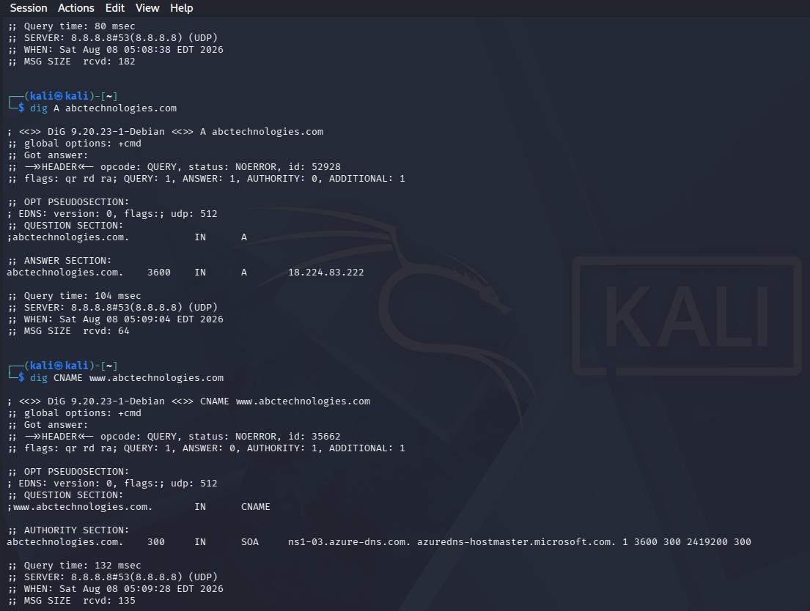

Topic 2: DNS Zone Transfers
- During an authorized penetration test, a security analyst suspects that the target organization’s DNS server is
misconfigured and may allow unauthorized DNS zone transfers.
Task: Apply the appropriate DNS command or tool to verify whether zone transfers are permitted. If the
transfer succeeds, explain how the retrieved DNS records can be used to identify internal hosts, mail servers,
and subdomains during reconnaissance.

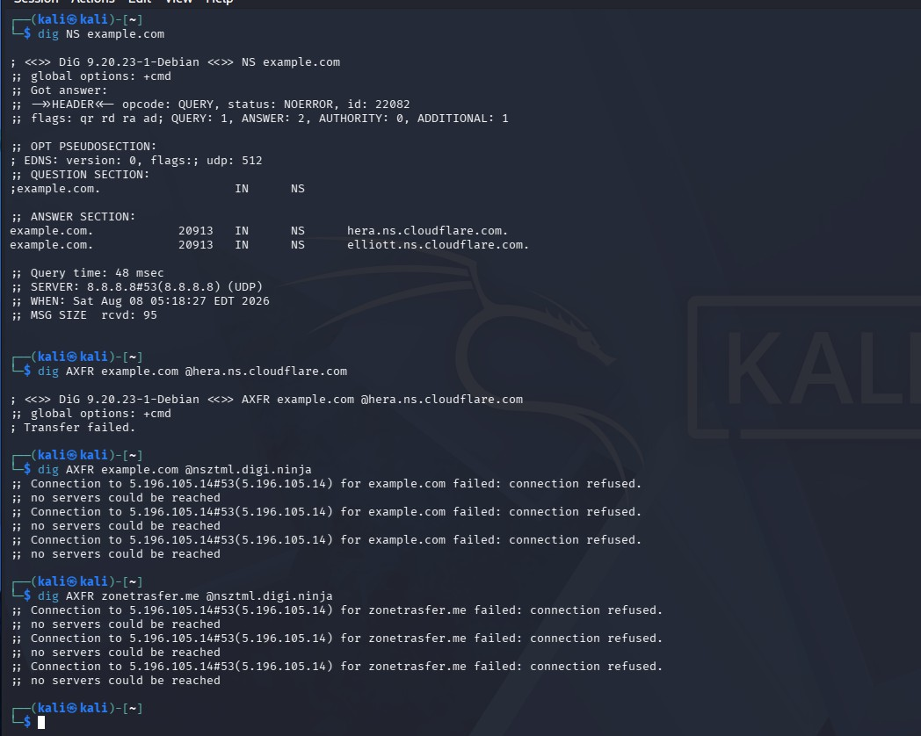

Topic 3: Introduction to Social Engineering – Social Engineering Attacks and Countermeasures
- Employees of an organization receive an email claiming to be from the IT department, asking them to verify
their login credentials through a provided link because of an urgent security update.
Task: Identify the type of social engineering attack and apply suitable countermeasures that employees
should follow before responding to the email. Explain how these actions help prevent credential theft.

Type of Social Engineering Attack
The given situation is a Phishing Attack, specifically credential phishing.
The attacker sends an email pretending to be from the organization's IT department and asks employees to verify their login credentials using a provided link. The attacker uses urgency and fear to make employees act without properly checking the email.

Indicators of a Phishing Email
Employees should look for the following warning signs:

Unknown or suspicious sender address
  - Urgent or threatening language, such as “verify immediately”
  - Unexpected request for username or password
  - Suspicious links or unfamiliar domain names
  - Spelling or grammatical mistakes
  - Unusual attachments
  - Email requesting sensitive information through a link

Countermeasures Employees Should Follow
- Verify the sender
Check the complete email address and confirm that it belongs to the organization's official domain.

Do not click suspicious links
Employees should avoid clicking links in unexpected emails, especially links asking for login credentials.

Check the URL
Hover over the link without opening it and verify whether it points to the organization's legitimate website.

Contact the IT department
Confirm the security-update request through an official phone number, help desk, or other trusted communication channel.

Never share passwords through email
Employees should never enter or send passwords in response to an unexpected email request.

Access the official website manually
Instead of clicking the email link, employees can type the organization's official website address directly into the browser.

Report the suspicious email
The email should be reported to the organization's IT/security team so that other employees can be protected.

Delete the email after reporting
Once reported, the suspicious email should be removed to prevent accidental interaction later.

Enable Multi-Factor Authentication (MFA)
MFA provides an additional layer of security even if a password is accidentally exposed.

Conduct security awareness training
Regular employee training helps staff recognize phishing, impersonation, urgency-based manipulation, and other social engineering techniques.

How These Countermeasures Prevent Credential Theft
These actions create multiple layers of protection against credential theft. Checking the
sender and URL helps employees identify fake communication. Avoiding suspicious links prevents them from reaching fraudulent login pages controlled by attackers. Verifying the request with IT confirms whether the security update is legitimate before any action is
taken.
Employees should also never provide passwords through email links, while MFA provides additional protection if credentials are compromised. Finally, reporting suspicious emails
helps the security team block similar attacks and protect other employees.

Conclusion
The email represents a credential-phishing social engineering attack that uses impersonation and urgency to steal employee login information. By verifying emails, avoiding suspicious links, contacting IT through trusted channels, protecting passwords,
reporting suspicious messages, and using MFA, employees can significantly reduce the risk of credential theft and unauthorized access.

